Highlander Memories

by Jeff Robinson

History, like genealogy, always challenges accuracy. I am writing about not only growing up in Piedmont, but also of other places visited in my youth. I will attempt to refrain from many personal stories, but I would bet that there will be too many anyway. My selected format for organizing this presentation is “hit or miss” and likely rambling. Spelling is by memory with the objective being to try to remember stuff!

I remember early elementary school that showed us how to excel in finger painting and taught us that the State Flower wasn’t Gold Medal. Recess taught us how to tell time by endless clock watching so we could go out and accomplish important events such as playing jacks, kick ball, hop scotch and dodge ball. Many varieties of paper airplanes were made and Cooty Catchers had surprises inside.
Lunch usually found us enjoying a brown bag peanut butter & jelly sandwich with a sharp eye out for a lucky classmate that had Hostess Cup Cakes “with the surprise inside & the white squiggly line frosting on top”. A popular class would be any, if when you came back from lunch, you found the movie projector set up. If you committed a classroom violation, you could have your desk moved to the cloak room or maybe be sent to see the Principal. Then the right and wrong was explained to you and you got to sit in the corner until the Principal couldn’t stand to have you there anymore.
Learning things at home was easier starting with Tinker Toys, then Pick-up Sticks moving up to construction with Lincoln Logs and Erector Sets. Staying home sick was made tough by Mom. You had to pretend to practice reading in your Little Golden Books of Dick & Jane or Bambi, but your toys or dolls were hiding under the covers. If Mom went to the store, that was a good time to empty the cereal boxes and get the toy out of the bottom before your siblings did. Maybe some Yo-Yo practice or Slinky time too. There were no treats allowed like Bosco and no TV either with your favorite shows like Romper Room, Brother Buzz, Beanie & Cecil, Karl the Karrot and Fireman Frank. However, Mom had a weakness for Queen For A Day, Dialing For Dollars, etc., so the TV was on for you to sneak looks at your stuff. I never appreciated the free TV via roof antennas back then.
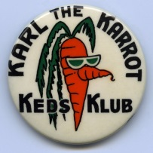
The streets were always quiet then with the only regulars being the Milkman, Mailman, Cleaners, Fuller Brush man and paperboy. The highlight of the week for the dogs was when the strong burly Italian Garbage Man came to steal all that stuff in the cans. Fido and Fifi got to explode and bark forever. We also found out that it was OK to play with matches, Ohio Blue-tips, if we raked up the dead leaves in the gutter to burn, unless we needed the leaves for making dams.
Guys wore US Keds and Levis that were too large on purpose since we were growing so fast. This required tall cuffs and patches from skinned knees to get the mileage out of them. Keds always had to be double knotted, but still wouldn’t work with clamp on roller skates. Bicycles usually had playing cards clipped on so the cards would make engine sounds in the spokes. The girls always looked nice in dresses and their Mary Jane’s.
Preschool is when they started taking stuff away from us, year by year. It began with “there is no boogy man under your bed”, then the Tooth Fairy, Halloween goblins, we got to keep the turkey and sandwiches, but the tough one was Santa Claus.
Valentines stayed around, but we found out why. It was a real “Game Changer” when the shocking and unbelievable “Birds and Bees” stories started going around in the Fifth grade! The girls had already started getting their training bras and engraved I.D. bracelets must have come next. Sometimes you might get a girl to wear yours for a while, a clear indication of going steady, even if you didn’t talk much. Little did we know that dances and stuff were right around the corner. Costume Birthday parties had ended by then and we had to go to work and got Oakland Tribune paper routes for a while. Elementary schools had Traffic Patrol with Sergeant Vacy, if your grades were good enough.

After having made it to the sixth grade as leaders of the school, you were then demoted to junior high and the lowly seventh grade. The large amount of kids was overwhelming, but slightly diffused by being placed in a homeroom arranged alphabetically. I think home room only taught you to not chew gum in class. Important classes were wood shop, print shop, study hall (with spit balls on the target clock) and PE. Brick Johnson tried to teach us how to box and climb the rope. The mile run often found some guys hiding behind the field house for one lap. PE on rainy days had the boys playing checkers in a room next to the girls PE. There were many fruitless attempts to try to see any of the girls when they did not have to wear the starched, shapeless middies. This is when we wanted to start shaving and try to look like the senior guys. Mr. Ferry seemed to be a step up toward fearful authority from your elementary Principal, but it was really only his more serious countenance.

The first day of senior high started with finding your new home room that was again alphabetized as were your new lockers. Many of us left the combination near the last number so we could open it immediately. I always wondered what home room was for, maybe attendance. The rest of the day was finding your classes and seeing who your teachers were and if you liked them.
One the best reasons to go out for sports was to shorten your day to only 6 periods. Athletes always had PE in the 7th period. It was possible to have only 4 “solids” with the others being homeroom, study hall, lunch, an elective and PE, if that was your agenda. The Deans, Mrs. Young, Mrs. McKay and Mr. McLain had direct authority over us. Keeping an eye on them wasn’t a bad idea or probably just McLain (Alex) since it was the boys that were always in some creative trouble. Cutting class and hiding in the park was skill to learn and usually didn’t start until later years. In our free time, most weeks began with a review and comparison of what we did over the past weekend. By Tuesday or so, plans were being made for which night was best to go to the Library or wherever we really would go. Some of us actually went to the Library once, just to check it out. It wasn’t very crowded. By mid-week people were planning or wondering about the weekend again. Exchanges often started with the question; “What are you going to do?” The answer was often; “I don’t know, what are you doing?” Anyway, something usually happened or you may find plenty of students sitting on steps at the stores watching the cruisers and waiting to see whose house was empty. As juniors, a new student came to Piedmont and wanted to make a name for himself. When seeing everyone hanging out at the stores, he drove his car up the steps and parked there to join them. That would of course be Finis Smith.
Many times, one of the guys would just shout “Let’s go to Tahoe! –so we did. Taking off on impulse made us feel like a big deal, but also because we could do it. Tahoe didn’t always slow us down because Nevada didn’t have speed limits then and places were open 24 hours, so there we went. Maybe as far as Winnemucca or east of Carson City to Silver Springs. There were some places that interested certain guys that had names like the Star Light Room, Mustang, Penny’s, Kit Kat Ranch and Moon Light Ranch. Gambling here and there was fun and Tahoe usually happened in a day or so. Popular vices in those days were Olympia beer in the Stubby bottles. Peeling off the label to see how many dots were printed on the back went on for years. The dot count was from none through four. Four was rare, if ever. The rumor was that you could win something unknown with four. A few guys liked Country Club Stout and then there was the dreaded Rainier “Green Death” Ale. Most guys smoked Marlboro and ladies favored Salem Menthol. Being under age didn’t seem to usually matter, as it was also pretty slack back home. Drugs didn’t seem to show up until 1964 and later.
Auditorium events like the talent shows were fun. Sally Scudder and Janet Cappelli on guitars sang a pretty version of Scotch and Soda. Mr. Waxdeck started the first Bird Calling Contest a bit informally allowing various imitations. Jay Knowland got first prize imitating a rooster and a jungle bird and MaryAnn Endicott won second prize for doing a crying baby. Suzie White used to run around the halls squawking the call of her invented bird, the Chick-a-Saur us-Deluxe.
Rock and Roll was popular and a couple of radio stations then were KFRC 610 and KYA 1260. Stereo was trying to be perfected for LP’s. The Continentals was a band put together with John Sorba (piano), Larry Dorfman (sax), Bill Fratus & Mike White (guitars) and Denny Pierpont (drums). They had an idea to earn some money and arranged to use the Rec Center to put on a Piedmont Concert that they called “Continentals on the Loose!” They advertised this with posters and promoted it all around town. Admission was $ .35 cents. The event was more than successful, the place was packed and rowdy –a real blow out! Afterward, they went to collect their money, but Mr. Quail wouldn’t give them anything. He said it was just a “fund raiser”.
We were also very fortunate to have police officers that were our friends, if not our baby sitters. Their white cars with the cherry on top were actually friendly to wave to. Our numerous violations were usually treated with just “hand slaps” and they would send you home – if someone could drive. Jack Flood was a nice guy, city worker and a “wanna be” cop. His proudest times were when got to direct traffic as an auxiliary in his Levis and a uniform shirt with badge and got to blow his whistle! The night shift usually was only three guys. Two patrol cars and a guy in the office. Many beer can pyramids were built on their PD office lawn. I remember Sergeant Vacy, Yellick and the serious plain clothes Detective Lamp. A younger, very friendly cop came along later, Harry Derringer. He married Gail Hinchcliff.
College sports were usually limited to the Cal games. Baseball was the Pacific Coast League with the Oakland Oaks or the SF Seals until the Giants brought the big leagues to Candlestick Park. Pro football was played at Kezar Stadium with the SF 49ers and players like Y.A. Tittle, Joe “The Jet” Perry and Hugh McElhenny.

“The Stores" were built in 1913 as a Commercial Center. They were designed by Albert Farr, who also designed the City Hall and the Community Church. They were built because Piedmont was known as the "store-less"city.

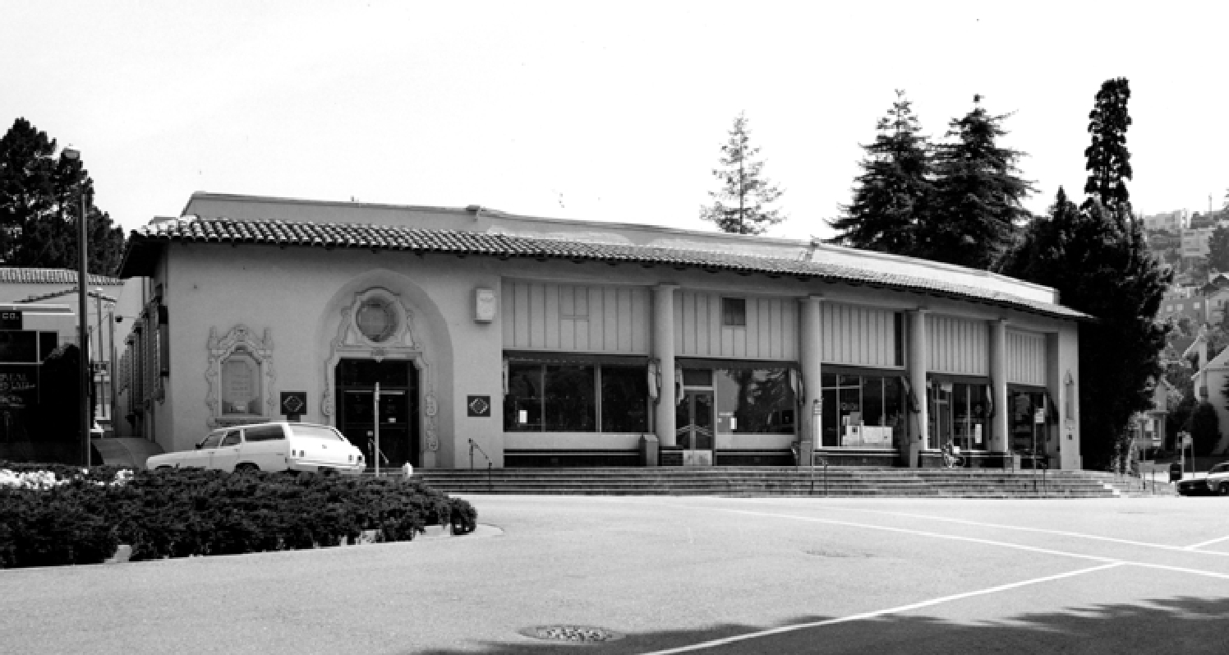

The Ainsworth Brothers were the first proprietors of the grocery store in 1915, followed by Ainsworth & Palmer in 1920, Ainsworth & Hamby in 1921, Hamby & Davis in 1923 and then Walter P. Hamby in 1925.

Harry & Mary Sund were the last owners of Hamby’s in the 1950’s & 1960’s.
There were many chores besides deliveries when I worked there, as did many students. Recycling the bottles was endless. They were poured into a large backroom bin until full and then we had to sort them by brand in to wooden crates and return them to companies like Coke. Cardboard was cut up and burned in a huge iron door furnace non-stop. The wooden, folding delivery boxes were all numbered and as each customer order was filled, we wrote the box numbers on the bill and stacked them out back. Then the bills had to be put in order of delivery for the driver. That wasn’t too hard because we knew every street and where to go first. When a truck backed up the alley, the boxes had to be loaded on in reverse. First delivery would be in the back obviously. Drivers would always just walk in the customers back doors and yell “Hamby’s”. Now and then we would walk in on housewives in various conditions and dress. Sometimes there were amazing stories to hear from the drivers – if you believed them.
Students came into the store and always stopped at the butcher counter for a free raw hotdog from Jack, Johnny or Leonard. They also bought lots of small French rolls with only a stack of salami as snacks. Kids also reached in the back of the hot peanut machine for a free handful of usually cashews or pistachio’s. Every night the butcher shop was thoroughly cleaned and the large cutting blocks were scraped and wire brushed down to bare wood.
There were 8 phone lines for orders that were busy. You had to write fast and in sort of a code. There were no customer account numbers, just names such as: Dollar on Sea View.
Many older customers were funny when they frequently sampled the produce and spit the cherry , apricot, etc. pits on the floor. Ralph was in charge of the produce. Upstairs was a veranda full of overstock. Harold was the manager who made stacks of cases to send down. We would prop up a long ramp to Harold that was steeply inclined down to the floor and he would slide down cases for us to catch. Some were light and easy such as cigarettes, but many were heavy and could take you out. Dog food was the worst. Remember that cases used to be larger. 24 was the common quantity, not 12 like these days. Then we had to put them all away on the shelves – dusting as you go.

Once a month the office upstairs had to get the bills ready to mail, a huge job and we had to help Mary Sund, Dixie and Sybil. Adding up the tags on a 10 Key hand crank machine and totaled to a statement took forever. Our privacy policy was to keep quiet, but we all knew that the largest and most famous accounts were the slowest to pay. They seemed to ignore the bills. When they were really reminded, they just wrote a huge check like it was no big deal – maybe it wasn’t to them.

Sybil was a very nice tiny older woman whose back was paralyzed in a 90 degree forward position. When she was sitting at her desk, you couldn’t notice any of this. At the end of every day, the office would call down that Sybil was ready to go to her car. Then one of us would hold her hand to walk her down all of the steps to get in her huge car. It was a blue 1958 Oldsmobile 88 four door with a V-8 engine. When I opened the door, I was shocked because it was a stick shift , 3 speed on the column. Then I saw the tall wooden blocks bolted to the pedals. Sybil was very short. She just got in and could barely see through the steering wheel. She fired it up and backed out of her parking spot very slowly. Then put it in first gear, waved to me and then took off like a teenager! She hit second gear up past the Chevron station. She was amazing !

Safeway also had a store across Highland that they built in 1940 and Foudy’s Fine Foods was on Grand Ave next to the Flying A gas station at Linda Ave. Foudy’s was a regular stop to get either a Twin-Pop, 50-50 bar or a Push Up Torpedo.

The first drug store was the Piedmont Drug Company in 1916. In 1936 it became Springman's Pharmacy. Mr. Springman ran it for years until his retirement when his son Phil took over until closing.

In 1921, Joseph Cheatham opened the Highland Sweet Shop with its candy store and soda fountain. This was later run by Gary Nottingham (Oakland band leader) and finally Marge & her daughter Gail. Gail later worked at Fenton’s. I remember that cherry cokes were popular and the French Burgers beat anything at the Quad. Jay Knowland worked there after school cleaning up. He was paid $ .50 per day plus a treat.

The service station was built in 1921, and ended up as a privately run Chevron franchise run by Harold Paulson (when he wasn’t at Bud’s Bar) and later L.A. “Babe” Morrow had it. Standard Stations were company owned and operated then. Babe and I were usually there alone and he taught me how to service and repair cars. Pumping gas usually had both of us provide full service. Babe tried to always be at the drivers window for small PR talk and cleaning the windshield over and over, especially if it was a women since they mostly only wore dresses back then. I would do the other glass and tires, but always offered to open the passenger door and wist broom the floor and empty the ash tray. Leo Kraft took my place when I left and he developed a successful business in that industry.

Across Highland was Buzz Turman’s Flying A gas station and also Ellen Driscoll’s Playhouse where the Sixth grade dances were held. The girls danced with girls learning The Bop or The Twist and the boys lined the walls hoping not to be noticed.

The American Trust Bank was added in 1928 and it later became a Wells Fargo Bank. Wells Fargo eventually raised the rents of the the stores tenants in 1969, which made most of them go out of business. Their plan was to construct a new building that was only their bank.

There was an alley to the left of the bank with a barber shop pole mounted there indicating to go behind the stores to the old Key System #10 streetcar right of way that also had a truck alley. That is where you would find the barber shop and a real estate office. Harold Hill started cutting hair there in the 1940’s. He was joined in 1962 by his son-in-law, Dennis Miller and Harold later retired in 1970 when the stores were demolished. The new commercial building still has the barber shop, Chaparral in the rear on Highland Way. Dennis’s daughter Sam, a PHS 1977 Alumni, joined him later and they are still turning out perfect haircuts! Dennis rescued the old barber pole and it is displayed in his Piedmont home.

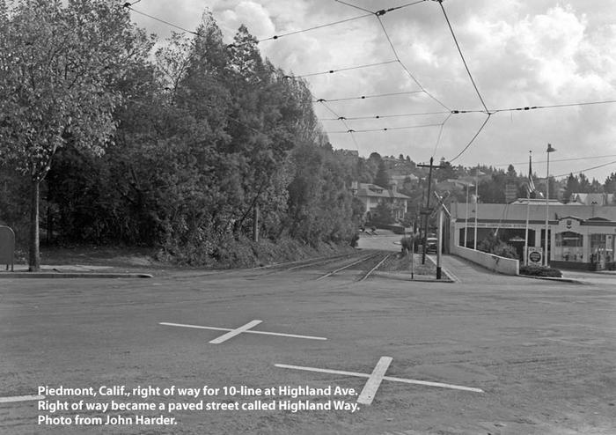

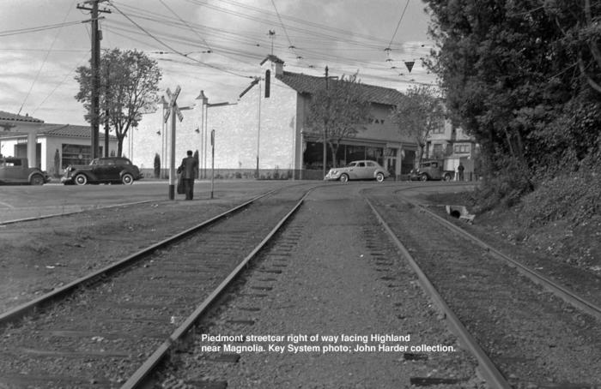
At 27th and Harrison was the Shepard Cadillac dealer in the old Piedmont Cable Car building. This out of the way location proved to be smart as most all of their customers lived in Piedmont and even the city bought a Cadillac ambulance from them. I wonder if the city was making a statement when they sped into a hospital emergency room on Pill Hill.

Higher up the hill in the Montclair Village was a unique Hansel & Gretel type firehouse built in 1927 and the Toy Chest. There was also a Lucky’s, clothing and jewelry stores, a couple of bars, gas stations, hamburger stand, a golf course, a sporting goods store and more. Lake Temescal was nearby, along with Rocky’s Market in Leimert. Skyline Blvd had some good “parking spots” and Roberts Pool was often a turnaround place. Due to fog, there were small white lights in the curbs. These caused driving and racing with no headlights on. Coming down Joaquin Miller and accelerating to launch north onto the Warren freeway allowed for various racing scenarios. Out Redwood Road were the horse stables and a couple of bars. The one on the left had a pool table, but the one on the right was a real serious cowboy butt kick’n bar. You only looked in the door there one time and got out quick while you could. Further out was the lake where some girls teased that they skinny dipped there. Past that was the challenging motorcycle hill climbs. I won a couple of bets by making it up somehow, near sideways in a 1956 Chevy car that I bought from Susan Gilberd.

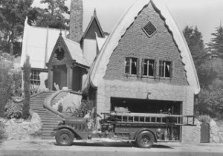

Popular play spots were Hampton Field, Tyson Lake, Piedmont Park, Dracena Park and Mountain View Cemetery where we learned to drive, fished in the three lakes and prowled at night doing creative teenage pranks and even skunk hunting. Up at the Cross was a place to spin donuts. The Cross burned down after it was struck by lightning . PHS had the football and practice field and the Rec Center is where you could play pool at lunch and certain guys hung out there showing off their 1950’s bad boy look, the Elvis-James Dean hair styles with a DA (Ducks Ass) that required a lot of Brylcreem. Smoking was optional – sort of, but Lucky Strikes made them look tough with leather jackets – Kookie, Kookie, lend me your comb…

The girls always entertained the city while cruising with their coded horn honking to friends and the Oakland Ave bridge had a rifle range inside of it. Arroyo was a popular hill to speed down and turn off your key as long as you dared. Turning it back on would produce a huge backfire. Some left it off too long and blew off their muffler or floor boards. A constant sight were the green Hamby’s trucks flying around town. Denny Pierpont liked to show off by burning past the stores, power shifting to second gear with a six cylinder engine and somehow still made the turn by the Community Center. The cops never gave the drivers tickets then.

Several fun places in our youth were Children’s Fairy Land where you could go down in Willie the Whale and Snow’s Museum at Lake Merritt. Going to the city began with the “Cover The Earth” neon sign in motion from Sherwin-Williams Paint while on the way to maybe the opera or better Fleishhackers Zoo, Steinhart Aquarium, the Cliff House and Playland at the Beach. Now and then a trip to the Santa Cruz Boardwalk was fun. In 1955, a trip to Anaheim, Calif. was mandatory for the opening of Disneyland. I can still see Grandpa with rolls of dimes, as the rides were from 10 to 30 cents each. Adults had to pay one dollar to get in.

Fall began many activities for the year. PHS sports started with night football games and win or lose, loud music blasted from our team shower room with Little Richard singing Jenny Jenny, Slippn’ & Slidn’ or Long Tall Sally. The dances at the Church followed the game with some interesting stories there. Basketball timing could coincide with skiing at Heavenly Valley, Sugar Bowl or Squaw Valley. Easter or Spring Break was called Hell Week and the city of Carmel or ‘Mel was buried with teenagers. I remember bathtubs filled with beer & ice and many beach parties south of town with big bonfires. The city was always glad when we all left. We also enjoyed Stinson Beach and left our mark on it or at least in the newspapers.

Downtown was Capwell’s, The Hofbrau, Payless Drugs and The Fox and Paramont Theaters. There was Sherman and Clay, Roos Brothers Clothing, I. Magnin, Breuner’s Furniture, Kahns, DeLauer’s News Stand and the Tribune Tower. Also the Doggie Diner, Kelley’s Sporting Goods on Telegraph that supplied most of our needs as did Siegels Guns on MacArthur. Then Casper’s, Bertola’s, Trader Vic’s, RollerLand and Mel’s Drive In.

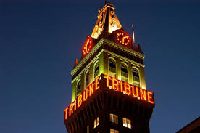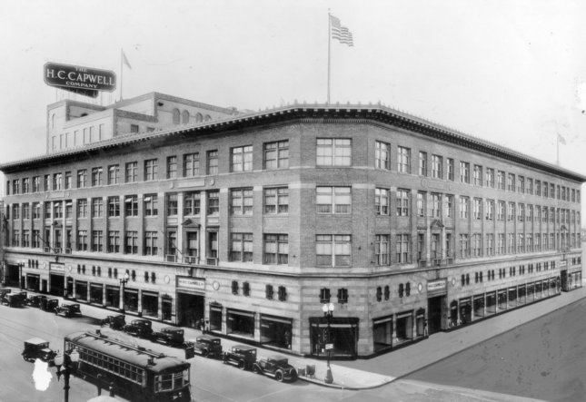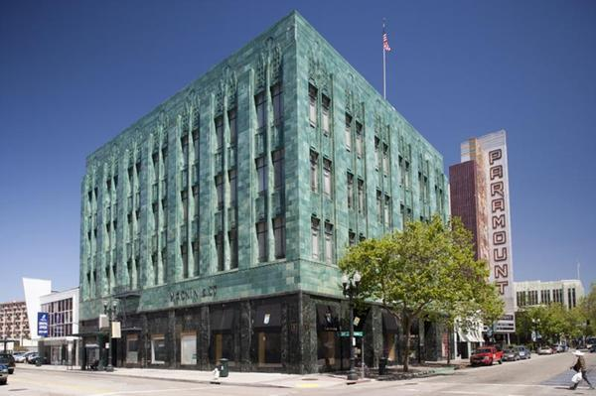

Jack London Square had the First and Last Chance Saloon, Casuals on the Square, Sea Wolf and Bow and Bell restaurants. Fireworks were always at Lake Merritt on the Fourth and you could rent a tiny electric boat (love nest) at night. The Library was by the lake and you could go see the Bay Bombers at the Roller Derby.

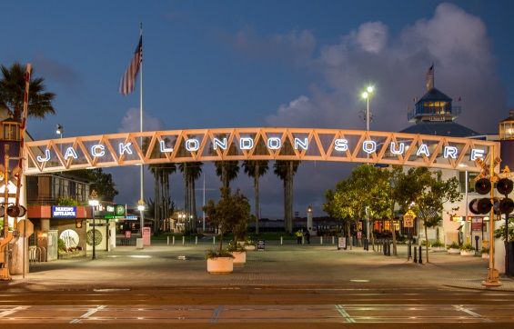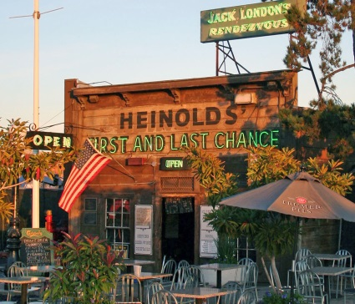

Through the tube was the Island Drive-In Theater where there was privacy and I heard that they even showed some movies there. South Shore Beach was on the other side of Alameda.

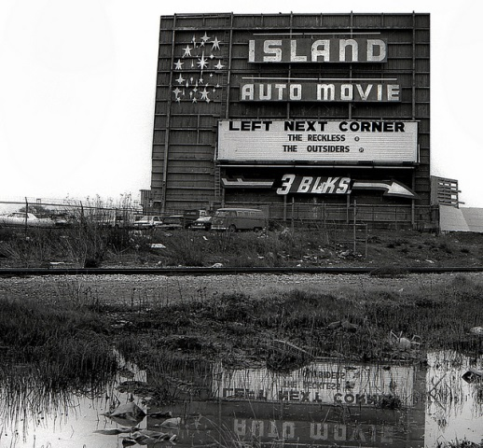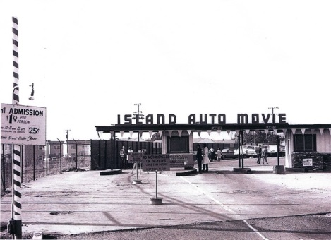

A few spots along Grand Ave were another barber shop, Shell gas station, Regal Liquors, Guys Drugs, Barney’s Ice Cream, the Rose Garden with the “Polio Pool”, Safeway, Mitch & Jim’s Sirloin, The Manhattan Club, Smitty’s, The Alley with a piano bar and Ron Dibble playing, Grand Lake Theater and Arthur O’Dell’s Photography.

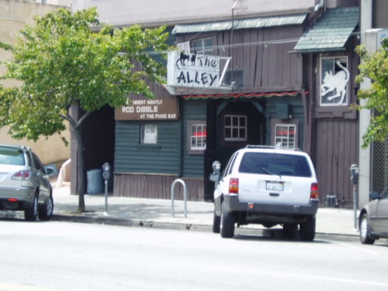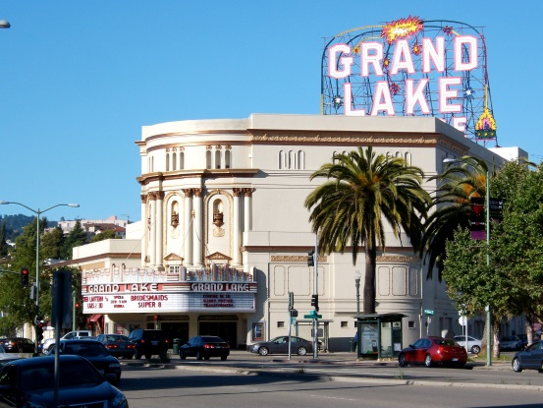

Heading up Lakeshore was the famous Kwik or Rat Way that was first called 19 for the burger price. Their burger was better than the PHS Quad only because of the “red sauce” (catsup & horseradish) and the three dill chips. Their fries were unique. Cut very long and skinny, saturated in grease so that they were translucent and the grease would drip off your elbow. A “Red Star” on your receipt made your order free if it happened.
There were many serious fights with the Oakland guys at Rat Way. Car paint damage happened with “Church Key” jobs done in the drive through that were traded off with the Oakland Cavaliers, Trojans and Esquires. Some Cavaliers got a little pushy one time. They had a couple of more guys than us, but we had size over them. Russ Heblack immediately went aggressive and got in their faces with an avalanche of threats, spraying his four letter words on them. Russ backed them off and they ran for it. He won the fight alone with incredible bluffs. We found out that the song “We are Piedmonts, fighting Clansmen” had more than one meaning. One time, Denny Pierpont and one friend tried to drive by a big crowd of guys in his convertible, but a guy swung a big chain at them. He missed them, but got the car. So two car loads of Oakland guys chased them and caught them at the stores and our guys had to hide in the park. They watched as the first thing to go was the windshield with the chain. A crow bar started with the headlights and so on, while others jumped on the hood and kept bashing up the car. The good news is that the cops caught them in the act and they had to pay for the damage. Back then, fights were only bloody with property damage and Piedmont always held their own just fine or better.
These days the Oakland natives seem to stay in their town and just shoot each other.

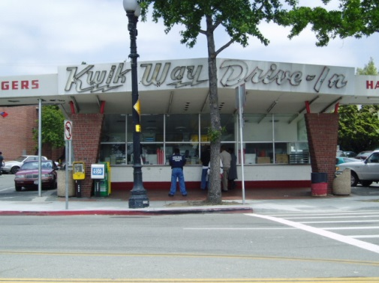
Around the corner was Confucius with Bing singing Tiny Bubbles, serving under aged kids and after hours for many. Then Oscars with the piano bar, fire pit, Oski steak and the Seven Souza brothers as owners. The Little Daisy was a very popular dress shop. A bar called the Lancers opened. It proved to be a place for “girlie” type guys that were coming out of the closet and they held hands and so on. Nobody wanted anything to do with that place. Across the street was the Donut Shop.

Piedmont Ave from MacArthur Blvd had the Army Navy Surplus Store, Record Shop, Mayfair Market, Lee’s Train (push on the window & the Lionel ran around), Bowling Alley, The Larder, Monte Vista Meats, Piedmont Grocery, 5-10-25 Cent Store, Gene Thomas Men’s Clothes, Longs Drugs (Joe & Tom Longs first store), Key System Train Station, Pearson’s Hardware, B of A, Nelmes Jewelry and the Kerry House. The Piedmont Theater had Saturday matinee cartoons and weekly serials. Candy cigarettes, Dots, Crows, Juicy Fruits, Milk Duds and Bon Bon’s were a few of the treats. The balcony let you throw popcorn down on others, while the teenagers sat in the back row “making out” or smoking. Some more places like the Post Office, McGinnis Barber Shop, Fenton’s with favorites like the Banana Special, Black & Tan, crab sandwich, etc., Ted’s Candy (he had one eye), Hagstrom’s Groceries. On the corner of Piedmont and Pleasant Valley was Piedmonts “watering hole”, Bud’s Bar. This was often a stop for the men coming back from work. Next door was Bud’s Liquor Store which was convenient to pick up something before heading up the hill to go home. Across the street was J. Miller Flowers, Seiferts Flowers, The Cole Honey Company with free samples and the gates into Mountain View Cemetery.
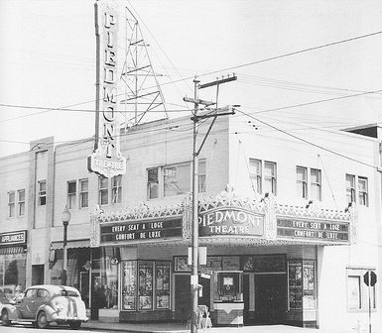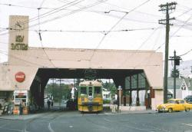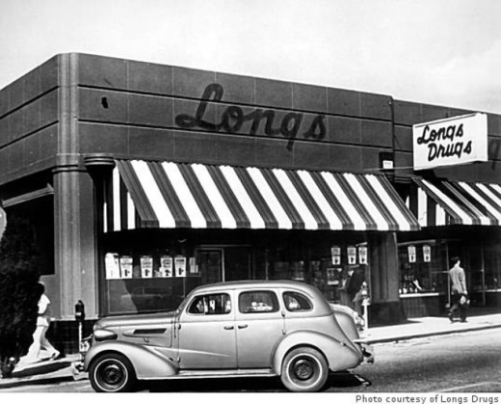

The end of the school year was always looked forward to which brought the Carnival and the dunking booths. When school was over came the freedom of summer vacation and favorite places to go. Camp Augusta, Camp Wallace Alexander, Tahoe, Huntington Lake, Russian River, Graeagle and many more places !

Thanks to our classmate, Gail Gibson Lombardi with the Piedmont Historical Society
for providing the details on “The Stores”

