Piedmont Men Lost in the Vietnam War

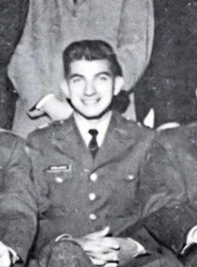 PHS 1956
Army CPT Chris Vurlumis with the 101st Airborne Div was KIA in 1966 by hostile fire after two months in country.

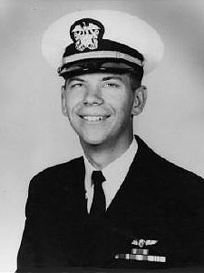 PHS 1960
Navy Lieutenant JG Tom Steimer was a F-4 Phantom weapon officer and was lost at sea in 1967 due to a power loss on a USS Kitty Hawk carrier launch.

PHS 1963
Marine Lance Corporal Tom Henshaw with the 3rd Mar Div was killed in 1967 by "misadventure" (friendly fire) after 8 months in country.

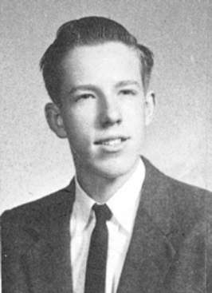 PHS 1963
Army Corporal Kendall Thompson with the 9th Inf Div was KIA in 1968 by hostile fire after 5 months in country.

